**Database Design Coursework**

Student Name: Tarun Kumar

Student ID: 240031489

Student Number: 240031489

**Scenario Topic Name** GetWell Massage Parlour

**Scenario**

GetWell Massage Parlour comprises of its customers, staff and facilities. Both staff and customers have unique IDs; the database records the latter’s details (name, address, age, etc) who have to apply for memberships. These have a start and end date, are either premium or standard and have different benefits: standard holders have features like limited sauna (according to a timetable) whilst premium has additional advantages like an unlimited sauna access and a private parking spot. Staff also have their details entered and have specific roles, including the management of other colleagues. A booking for a massage has an ID, time, receipt and can only be made by a customer once a day. The facilities are maintained by a designated staff member: they’re identified by their unique ID and the ID of the staff member in charge of it.

**Queries**

1. What type of memberships are offered?
2. Who is in charge of the facilities and making sure they are being maintained?
3. List the number of staff members working at the parlour.
4. How many bookings can a customer make per day?
5. Which are the benefits of having a premium membership?

**Entity Relationship Model**

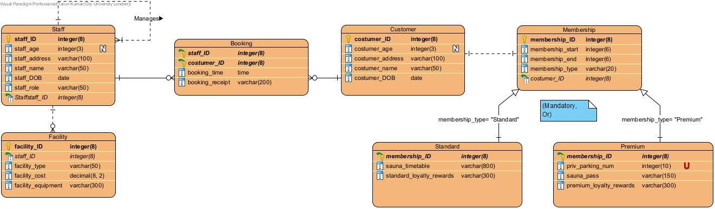

**Relational Model Tables**

|  |  |
| --- | --- |
| **Relational table specification** | **Marker’s corrections (Do not write in this column)** |
| **Table name:** Staff |  |
| **Attributes** |  |
| staff_ID |  |
| staff_age |  |
| staff_address |  |
| staff_name |  |
| staff_DOB |  |
| staff_role |  |
| Staffstaff_ID |  |
| **PRIMARY KEY** (staff_ID) |  |
| **FOREIGN KEY** (Staffstaff_ID) REFERENCES Staff (Staffstaff_ID) |  |

|  |  |
| --- | --- |
| **Relational table specification** | **Marker’s corrections (Do not write in this column)** |
| **Table name:** Facility |  |
| **Attributes** |  |
| facility_ID |  |
| staff_ID |  |
| facility_type |  |
| facility_cost |  |
| facility_equipment |  |
| **PRIMARY KEY** (facility_ID) |  |
| **FOREIGN KEY** (staff_ID) REFERENCES Staff(staff_ID) |  |

|  |  |
| --- | --- |
| **Relational table specification** | **Marker’s corrections (Do not write in this column)** |
| **Table name:** Booking |  |
| **Attributes** |  |
| staff_ID |  |
| customer_ID |  |
| booking_time |  |
| booking_receipt |  |
| **PRIMARY KEY** (staff_ID, customer_ID) |  |
| **FOREIGN KEY** (staff_ID) REFERENCES Staff (staff_ID) |  |
| **FOREIGN KEY** (customer_ID) REFERENCES Customer (customer_ID) |  |

|  |  |
| --- | --- |
| **Relational table specification** | **Marker’s corrections (Do not write in this column)** |
| **Table name:** Customer |  |
| **Attributes** |  |
| customer_age |  |
| customer_ID |  |
| customer_address |  |
| customer_name |  |
| customer_DOB |  |
| **PRIMARY KEY** (customer_ID) |  |

|  |  |
| --- | --- |
| **Relational table specification** | **Marker’s corrections (Do not write in this column)** |
| **Table name:** Membership |  |
| **Attributes** |  |
| membership_start |  |
| membership_ID |  |
| costumer_ID |  |
| membership_end |  |
| membership_type |  |
| **PRIMARY KEY** (membership_ID) |  |
| **FOREIGN KEY** (costumer_ID) REFERENCES Costumer(costumer_ID) |  |

|  |  |
| --- | --- |
| **Relational table specification** | **Marker’s corrections (Do not write in this column)** |
| **Table name:** Standard |  |
| **Attributes** |  |
| sauna_timetable |  |
| membership_ID |  |
| standard_loyalty_rewards |  |
| **PRIMARY KEY** (membership_ID) |  |
| **FOREIGN KEY** (membership_ID) REFERENCES Membership(membership_ID) |  |

|  |  |
| --- | --- |
| **Relational table specification** | **Marker’s corrections (Do not write in this column)** |
| **Table name:** Premium |  |
| **Attributes** |  |
| priv_parking_num |  |
| membership_ID |  |
| sauna_pass |  |
| premium_loyalty_rewards |  |
| **PRIMARY KEY** (membership_ID) |  |
| **FOREIGN KEY** (membership_ID) REFERENCES Membership(membership_ID) |  |

**Marker’s Comments** (Do not write in this section)

**Important:** Please note that marker’s corrections to your relational tables are there to help you construct a working database for the second coursework. They are not the determinant of your mark. For more information on how your work is assessed see the coursework specification and grade related criteria.

**Coursework Mark** (100 marks available):